**Name:** Wania Hijab Satti

**SAP ID**: 63686

**Subject:** PF Lab Assignment Submission



**TASK 1**

#include<iostream>

using namespace std;

int main() {

int num;

cout<<"Enter a number";

cin>>num;

int i;

for(i=1;i<=10;i++) {

cout<<num<<" * "<< i <<" = "<<(num*i)<<endl;

}

return 0;

}

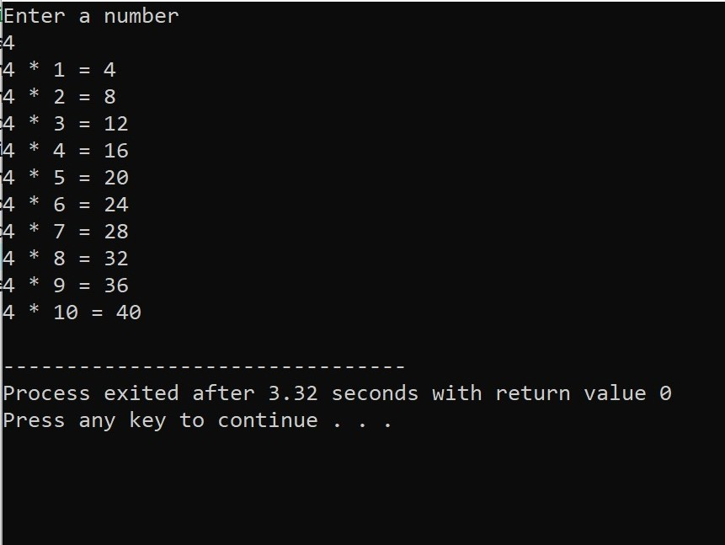

**TASK 2**

#include<iostream>

using namespace std;

int main() {

int num,num1;

cout<<"Enter a number greater than 1"<<"\t\t";

cin>>num1;

for(num=num1;num>0;num--)

cout<<num<<endl;

return 0;

}

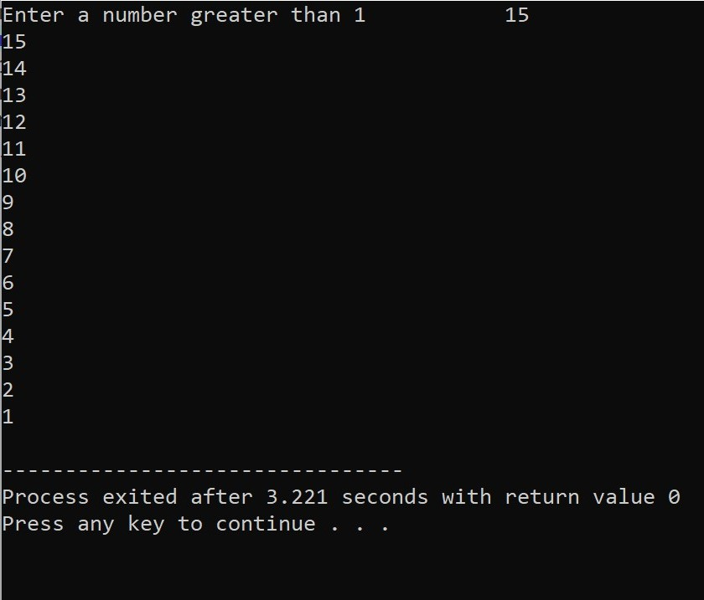

**TASK 3**

#include<iostream>

using namespace std;

int main() {

int number;

int sum = 0;

cout << "Enter a number ";

cin>>number;

while (number>=0) {

sum += number;

cout<<"Enter a number ";

cin>>number;

}

cout << "The total sum is: " << sum ;

return 0;

}

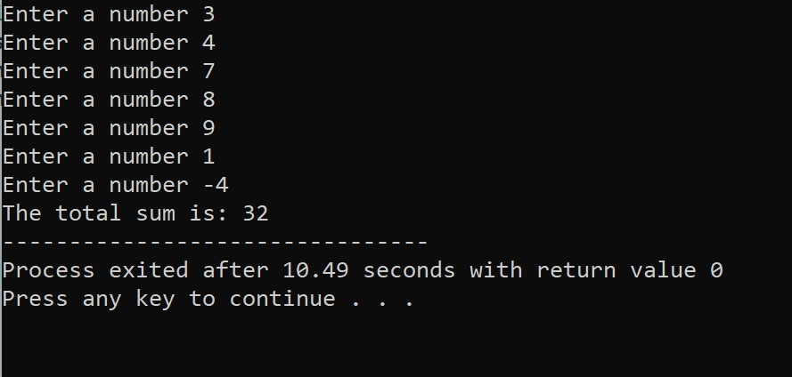

**TASK 4**

#include<iostream>

using namespace std;

int main() {

int n;

int sum = 0;

int i = 1;

cout << "Enter a number ";

cin >> n;

while (i <= n) {

if (i%2 == 1) {

sum += i;

}

i++;

}

cout << "The sum of all odd numbers between 1 and " << n << " is: " << sum << endl;

return 0;

}

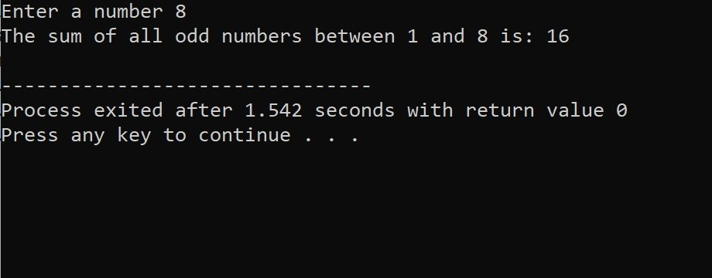

**TASK 5**

#include<iostream>

using namespace std;

int main() {

int temp1,temp2,temp3,temp4,temp5,temp6,temp7;

int sum,avg_temp;

cout<<"Enter temperature on Monday in Celsius"<<"\t";

cin>>temp1;

cout<<"Enter temperature on Tuesday in Celsius"<<"\t";

cin>>temp2;

cout<<"Enter temperature on Wednesday in Celsius"<<"\t";

cin>>temp3;

cout<<"Enter temperature on Thursday in Celsius"<<"\t";

cin>>temp4;

cout<<"Enter temperature on Friday in Celsius"<<"\t";

cin>>temp5;

cout<<"Enter temperature on Saturday in Celsius"<<"\t";

cin>>temp6;

cout<<"Enter temperature on Sunday in Celsius"<<"\t";

cin>>temp7;

sum=temp1+temp2+temp3+temp4+temp5+temp6+temp7;

avg_temp=sum/7;

cout<<"The average temperature of the whole week is "<<avg_temp;

return 0;

}

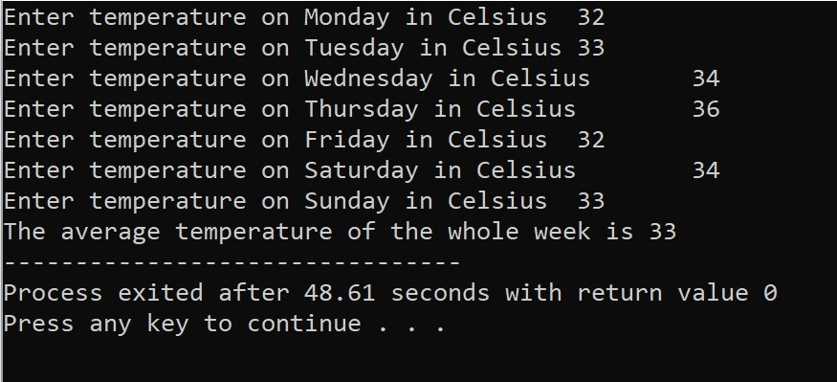

**TASK 6**

#include<iostream>

using namespace std;

int main() {

double balance;

double withdrawl;

cout << "Enter initial balance: ";

cin >> balance;

while (true) {

cout << "Enter amount to withdraw: ";

cin >> withdrawl;

if (withdrawl == 0) {

break;

}

if (withdrawl > balance) {

cout << "Insufficient balance. Transaction declined."<<endl;

} else {

balance -= withdrawl;

cout << "Transaction successful. Current balance: " << balance<<endl;

}

}

return 0;

}

